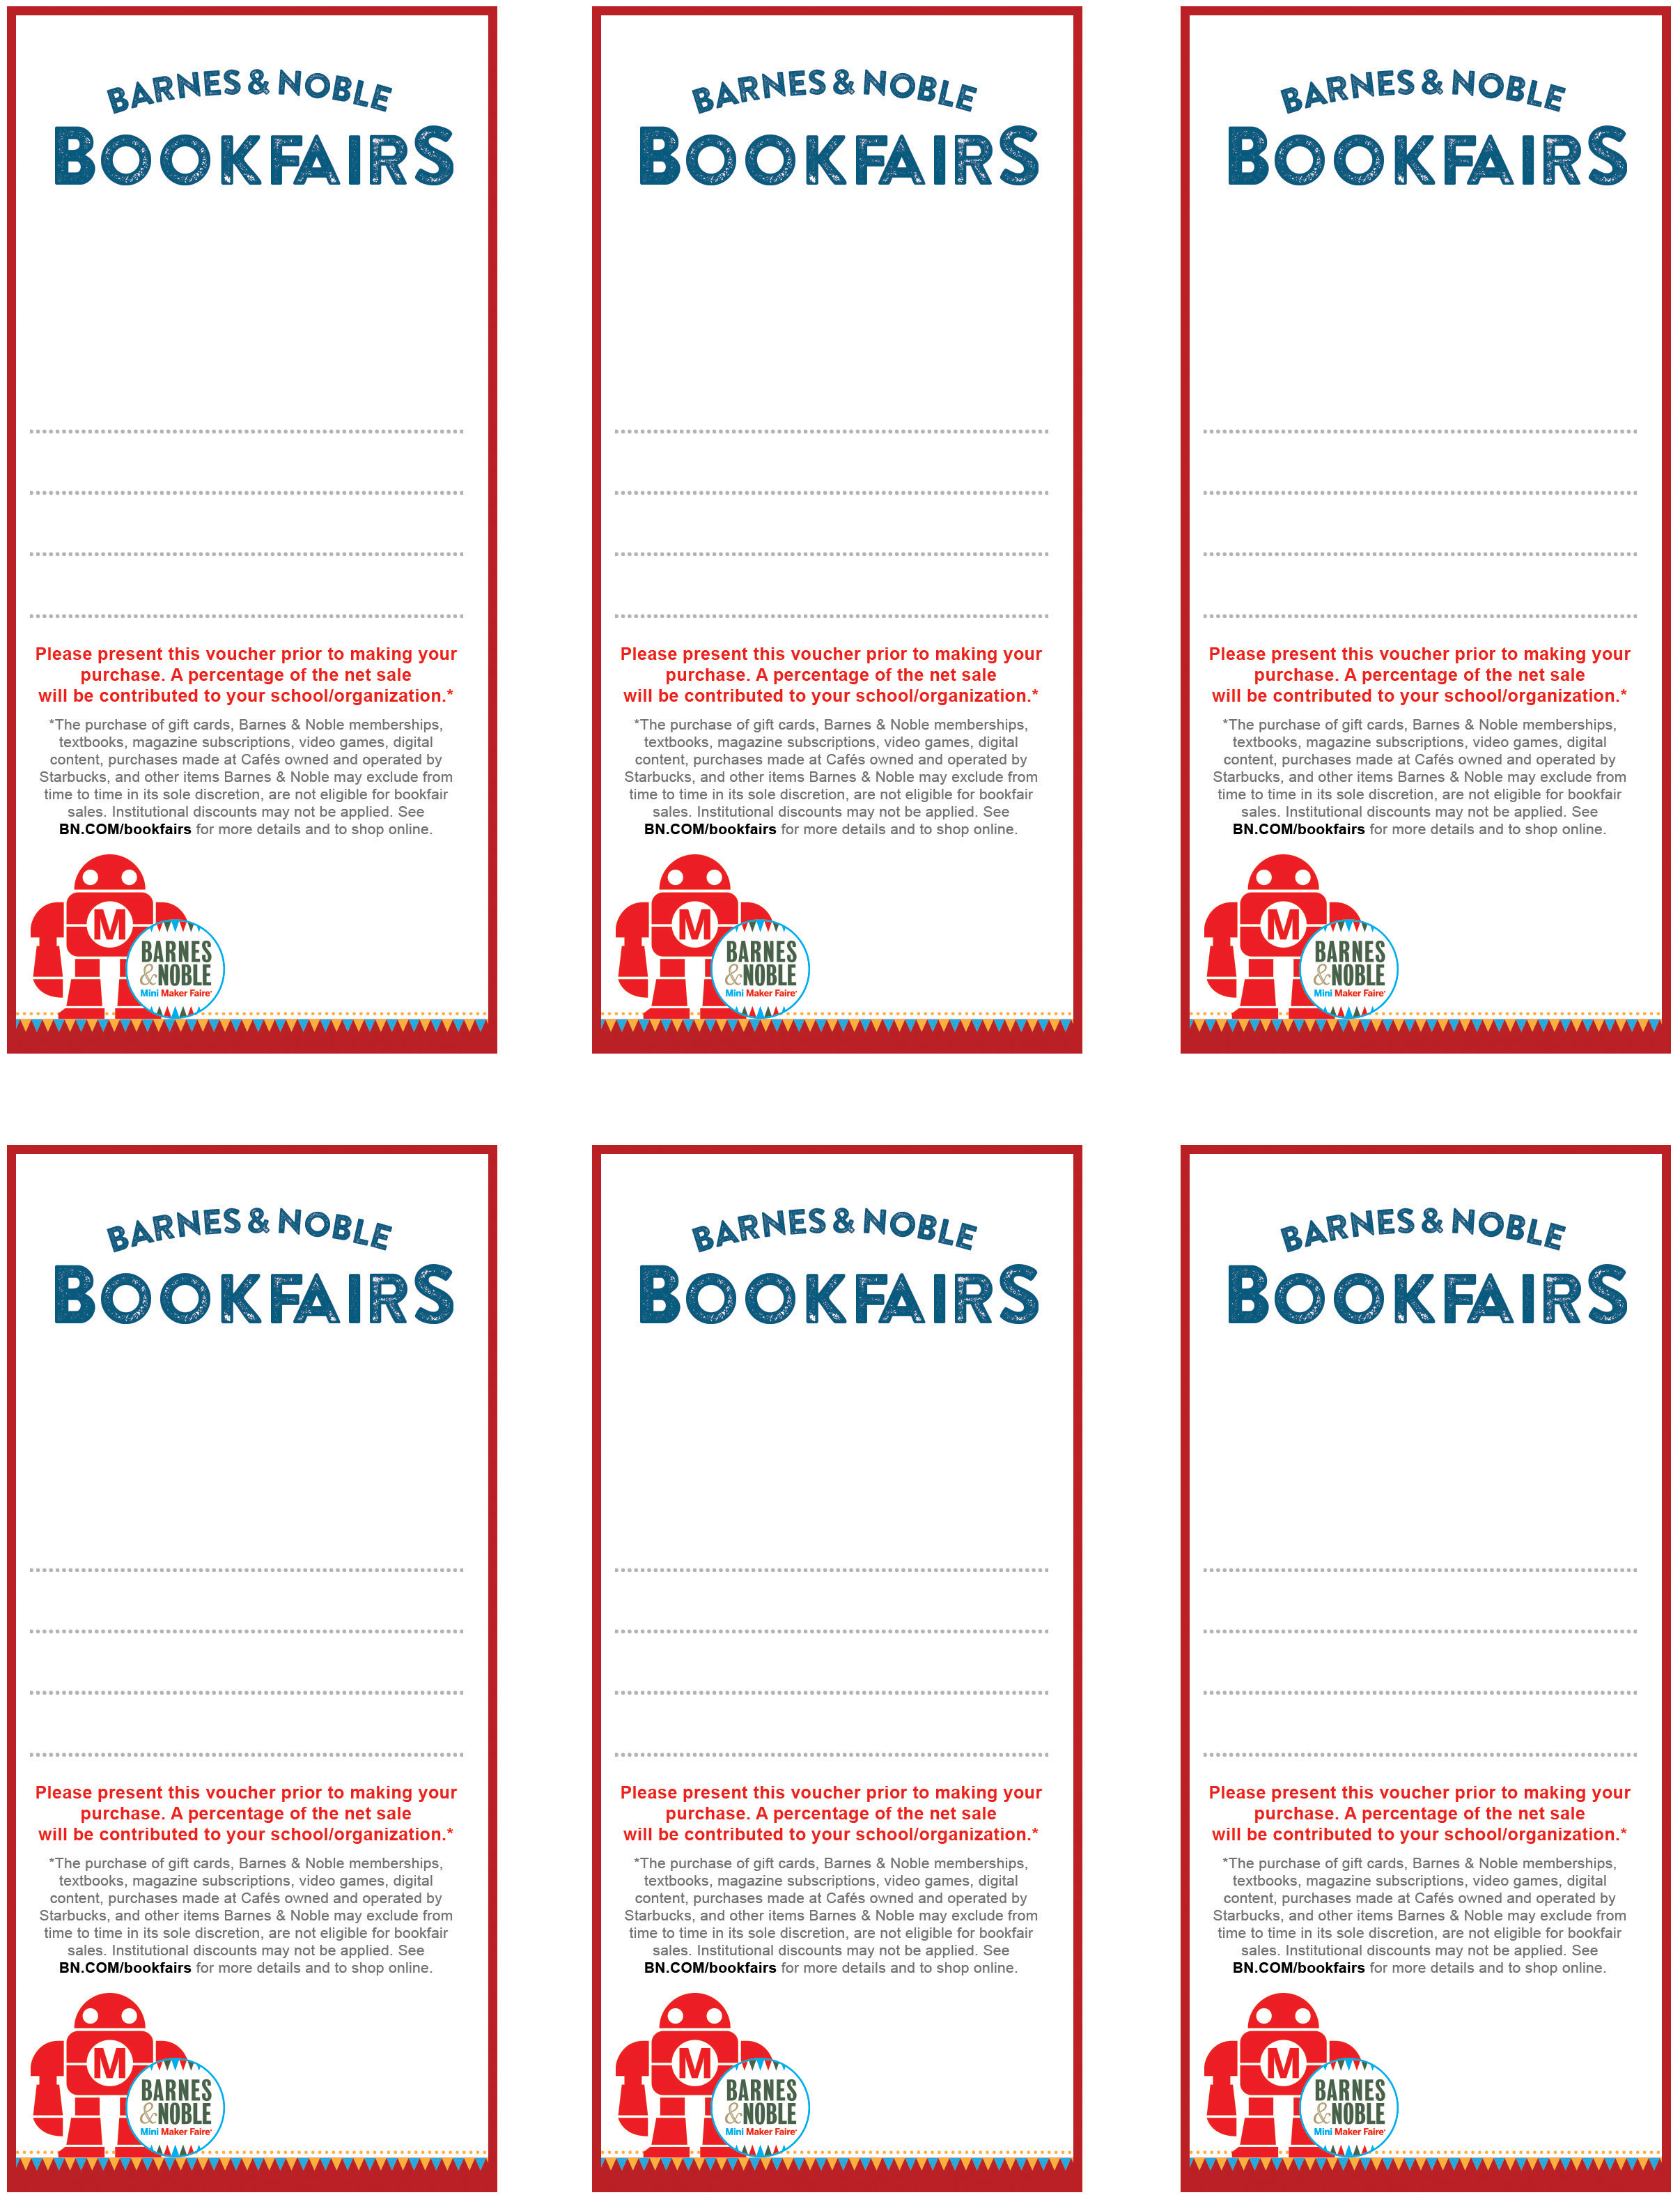
Nov 4th – 6th
Barnes & Noble Snellville
1350 Scenic Hwy
Bookfair ID 11951498

Supporting

GSMST

Nov 4th – 6th
Barnes & Noble Snellville
1350 Scenic Hwy
Bookfair ID 11951498

supporting

GSMST

Nov 4th – 6th
Barnes & Noble Snellville
1350 Scenic Hwy
Bookfair ID 11951498

supporting

GSMST

Nov 4th – 6th
Barnes & Noble Snellville
1350 Scenic Hwy
Bookfair ID 11951498

supporting

GSMST

Nov 4th – 6th
Barnes & Noble Snellville
1350 Scenic Hwy
Bookfair ID 11951498

supporting

GSMST

Nov 4th – 6th
Barnes & Noble Snellville
1350 Scenic Hwy
Bookfair ID 11951498

supporting

GSMST

